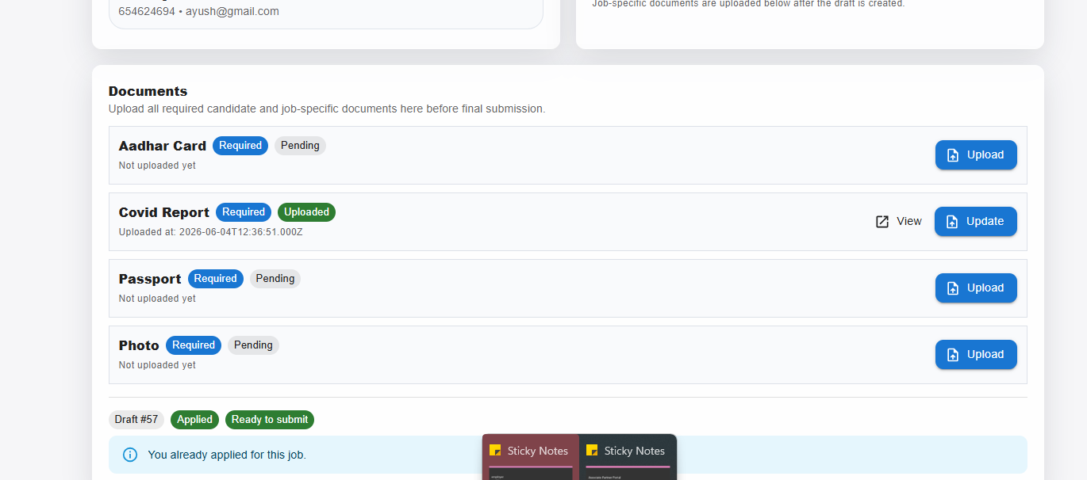
- Associate Partner https://sisglobalapp.neuralinfo.co.in/portal/associate/job/apply-candidates
- Solve the Document Validation (keep that which is not uploaded )
- And remove the Not uploaded yet
- Already uploaded still showing required and pending
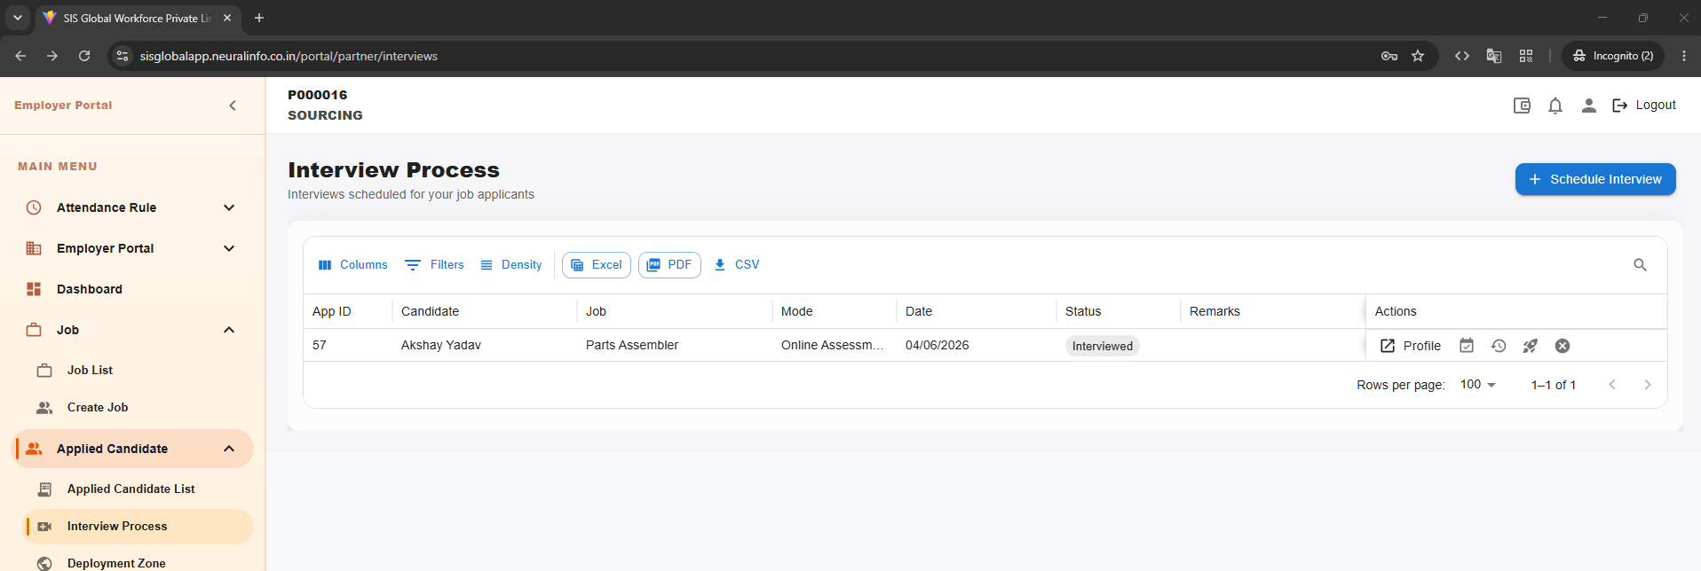
- https://sisglobalapp.neuralinfo.co.in/portal/partner/interviews
- Add tooltip in actions
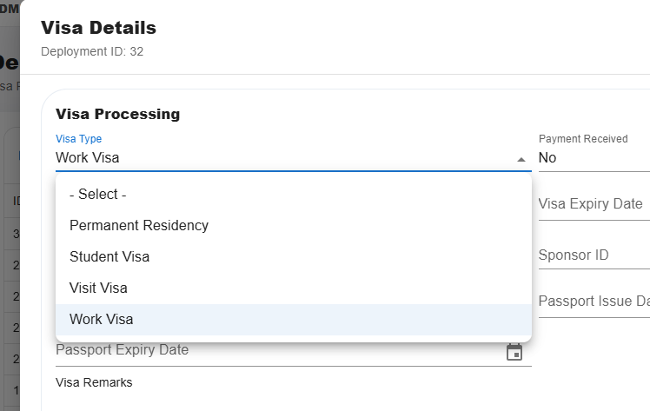
- https://sisglobalapp.neuralinfo.co.in/portal/deployment/visa-processing
- Visa type is only Work Visa
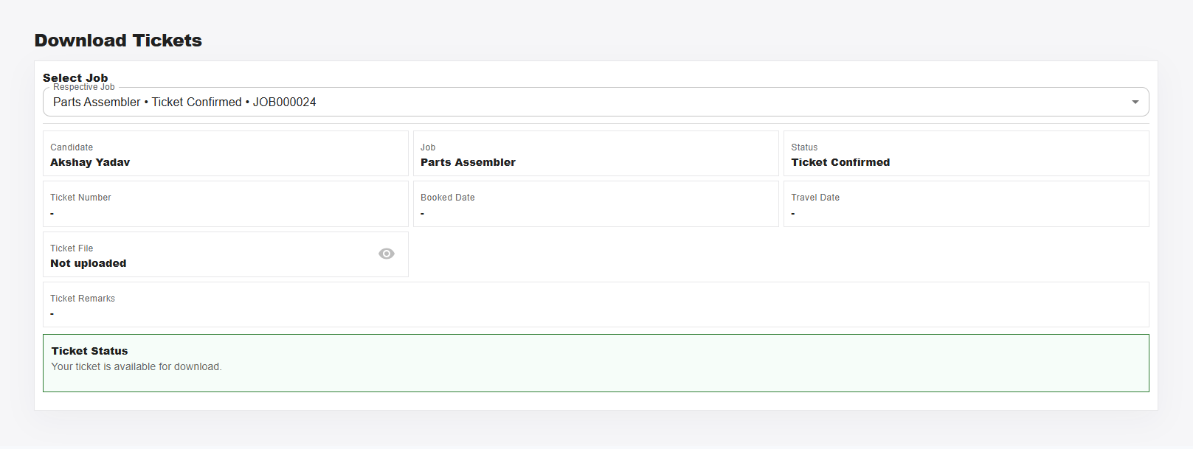
- https://sisglobalapp.neuralinfo.co.in/portal/candidate/onboarding/tickets
- Without any inputs the flow is move forward
- Validation
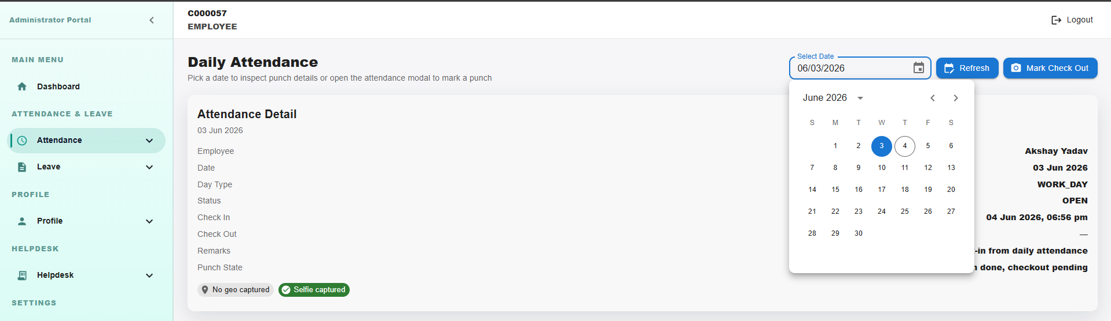
- https://sisglobalapp.neuralinfo.co.in/portal/employees/attendance/daily-attendance
- Validation required for the Attendence (add restriction to mark attendance of previous date)

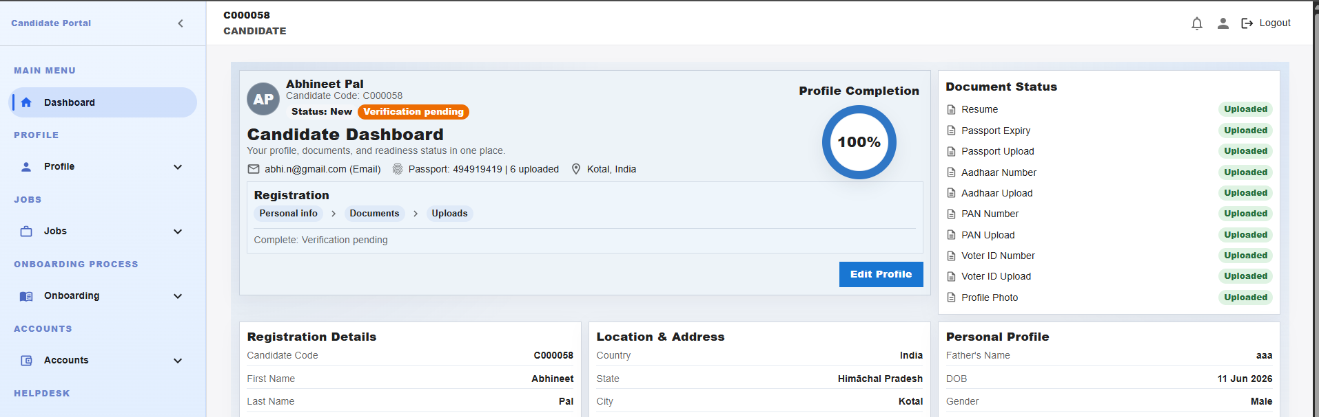
- https://sisglobalapp.neuralinfo.co.in/portal/candidate/home
- [12:11, 6/3/2026] Sheetanshu Sir Neural Info Solutions: it should not be mandatory, also if progress is showing 100% it should allow to approve
- [12:12, 6/3/2026] Sheetanshu Sir Neural Info Solutions: don;t restrict user much, we should show * as mandatory and option shouldn't have blank
address 2

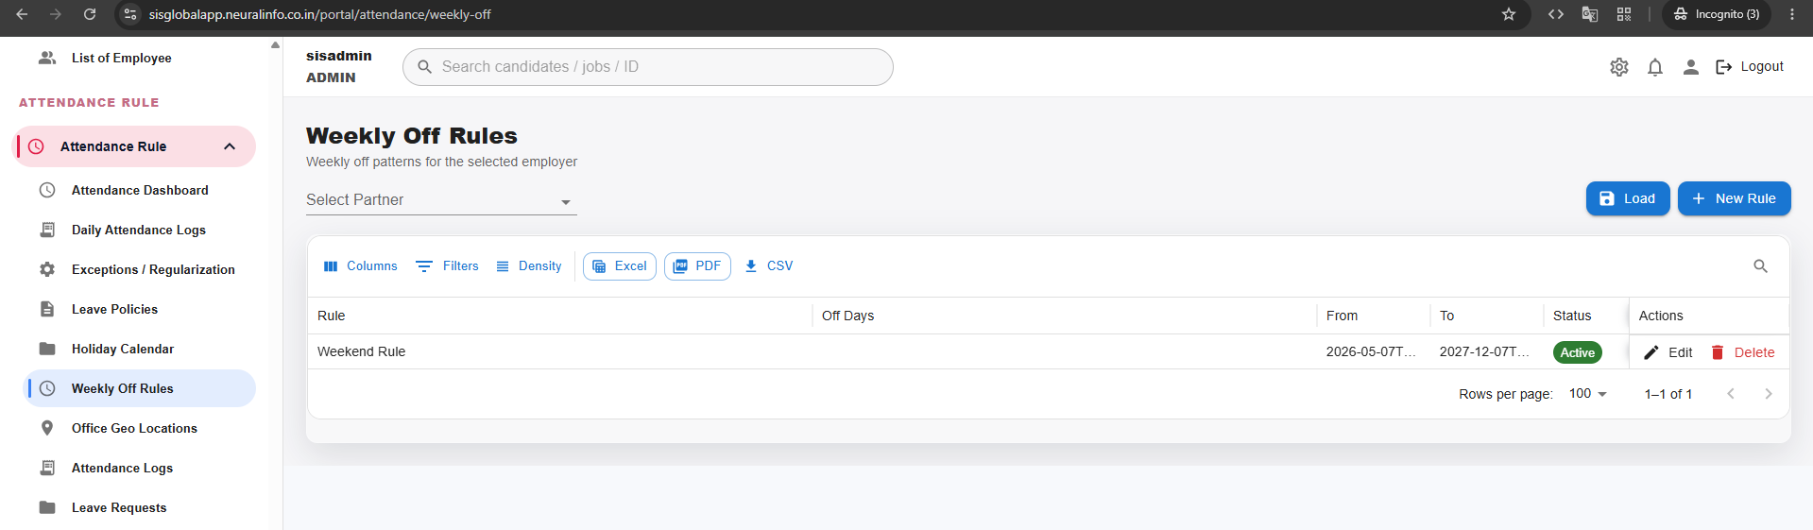
- DDMMYY
- https://sisglobalapp.neuralinfo.co.in/portal/attendance/weekly-off

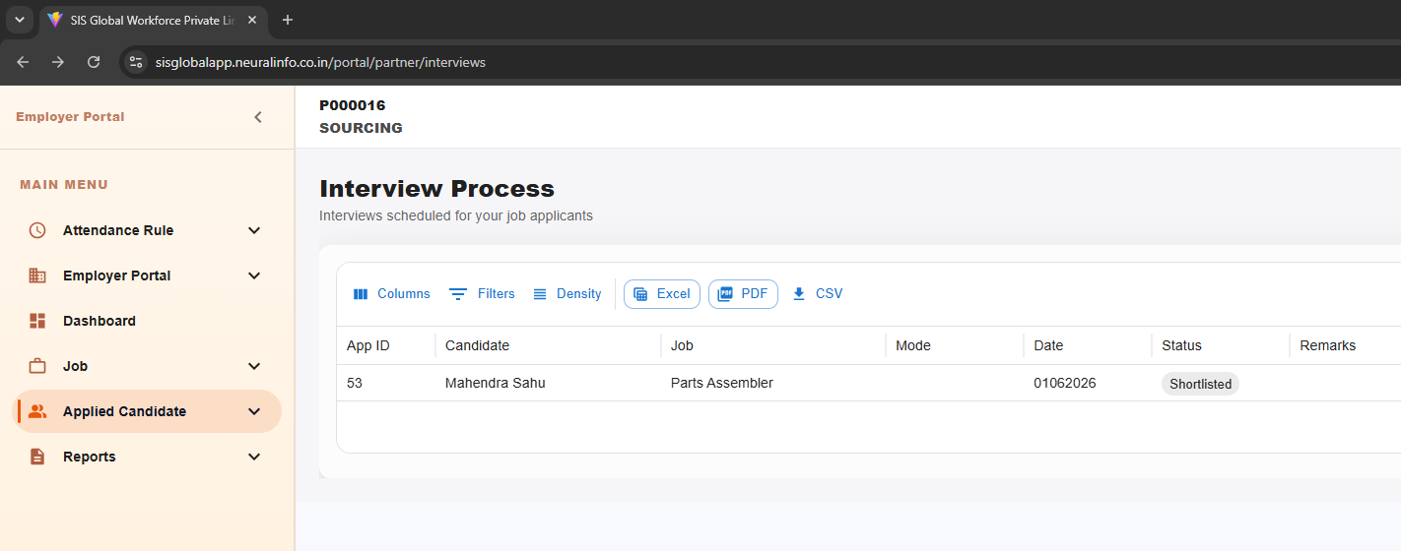
- https://sisglobalapp.neuralinfo.co.in/portal/partner/interviews
- Date format

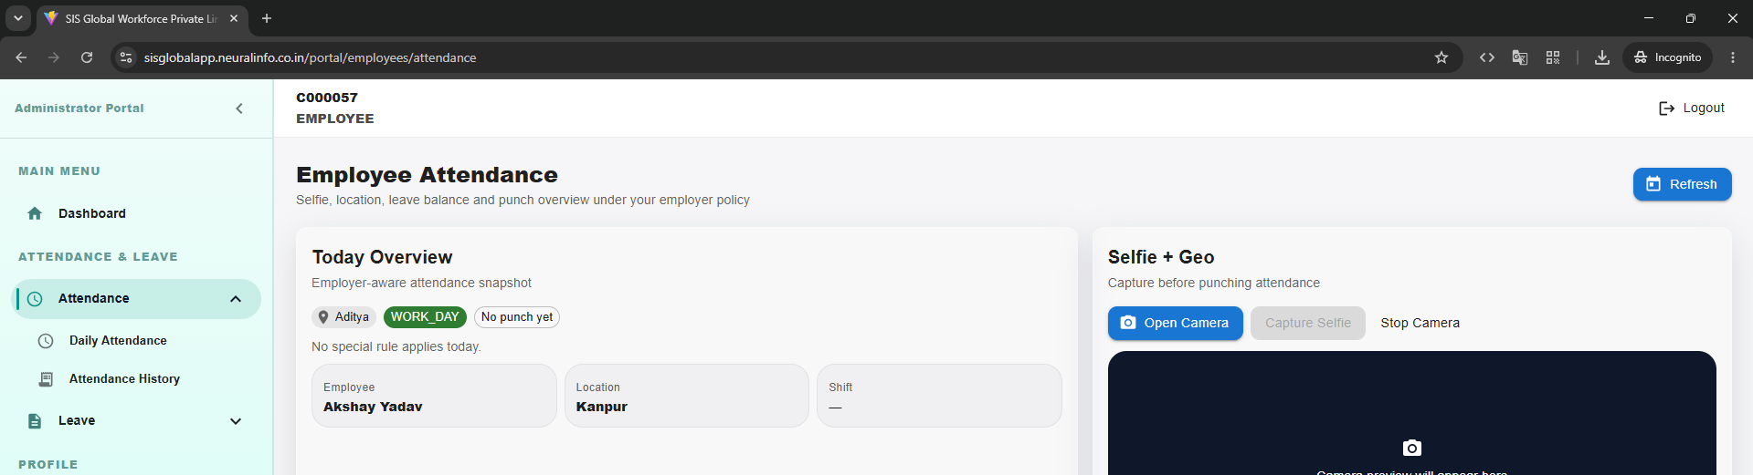

- Login as an Employee.
- Open:
https://sisglobalapp.neuralinfo.co.in/portal/employees/attendance
- Manually change the URL to:
https://sisglobalapp.neuralinfo.co.in/portal/employees
- Observe that the employee can view the full employee list.
Result: Unauthorized access to all employee records.
Expected Result: Employee should receive "Access Denied" or be redirected to an authorized page.

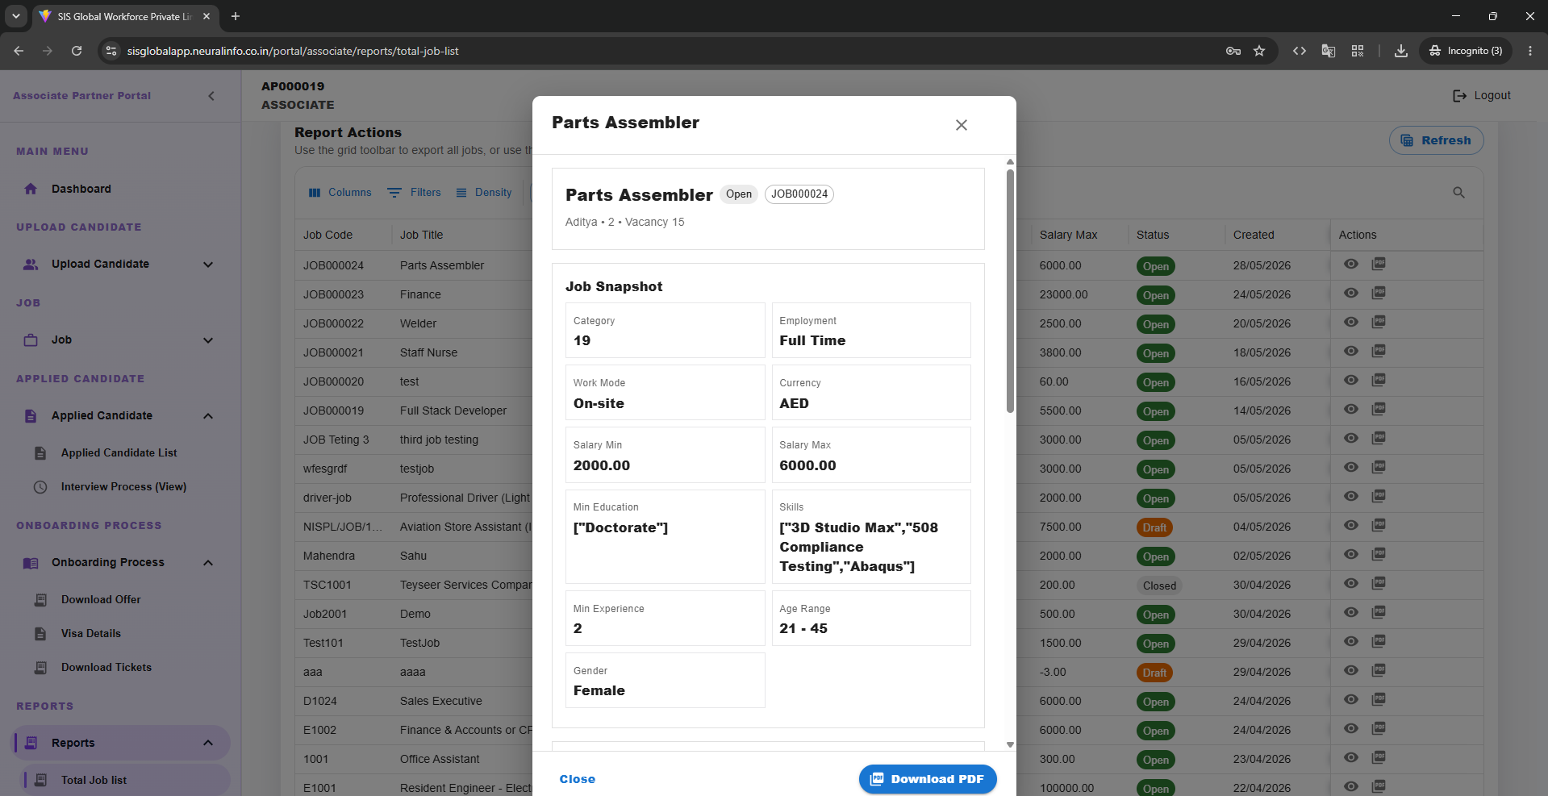

- https://sisglobalapp.neuralinfo.co.in/portal/associate/reports/total-job-list
- Skills and min eduction should be in good format like in bullets

